Product Information & Catalog copy
Desert Locust® Military Goggle System
The Desert Locust combines the best ballistic protection and widest field-of-view with a perfect facial and helmet fit, making it the ultimate protective eyewear for extended use. Tough enough to withstand a shot gun blast from 16 ft. (5m) away.
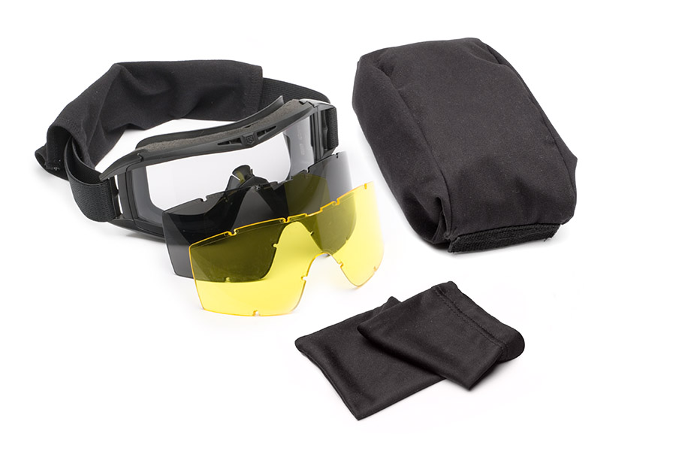
- High-impact*, optical grade polycarbonate lens shields eyes from unexpected fragments and offers 100% protection from UV-A, UV-B and UV-C rays
- High performance OcuMax® coating protects against fogging and scratching; top and lateral forced air vents maximize air circulation; filtration media prevents small particle entry
- Superior anti-scratch hard coating for durability in extreme climatic conditions
- Three interchangeable lenses for various light conditions –Clear, Solar and High-Contrast±±
Desert Locust Goggle Deluxe Kit shown
- At only 4 ounces, this lightweight goggle can be worn comfortably for hours
- Pliable frame material and strapping system seals face while maximizing facial comfort
- Low profile design ensures compatibility with helmet, weapon sights, binoculars and night-vision systems
- Optional Prescription (Rx) Carrier available (Also compatible with Sawfly® Spectacles and Bullet Ant® Tactical Goggles)
- Deluxe Kit also includes protective sleeve, microfiber lens pocket and storage case
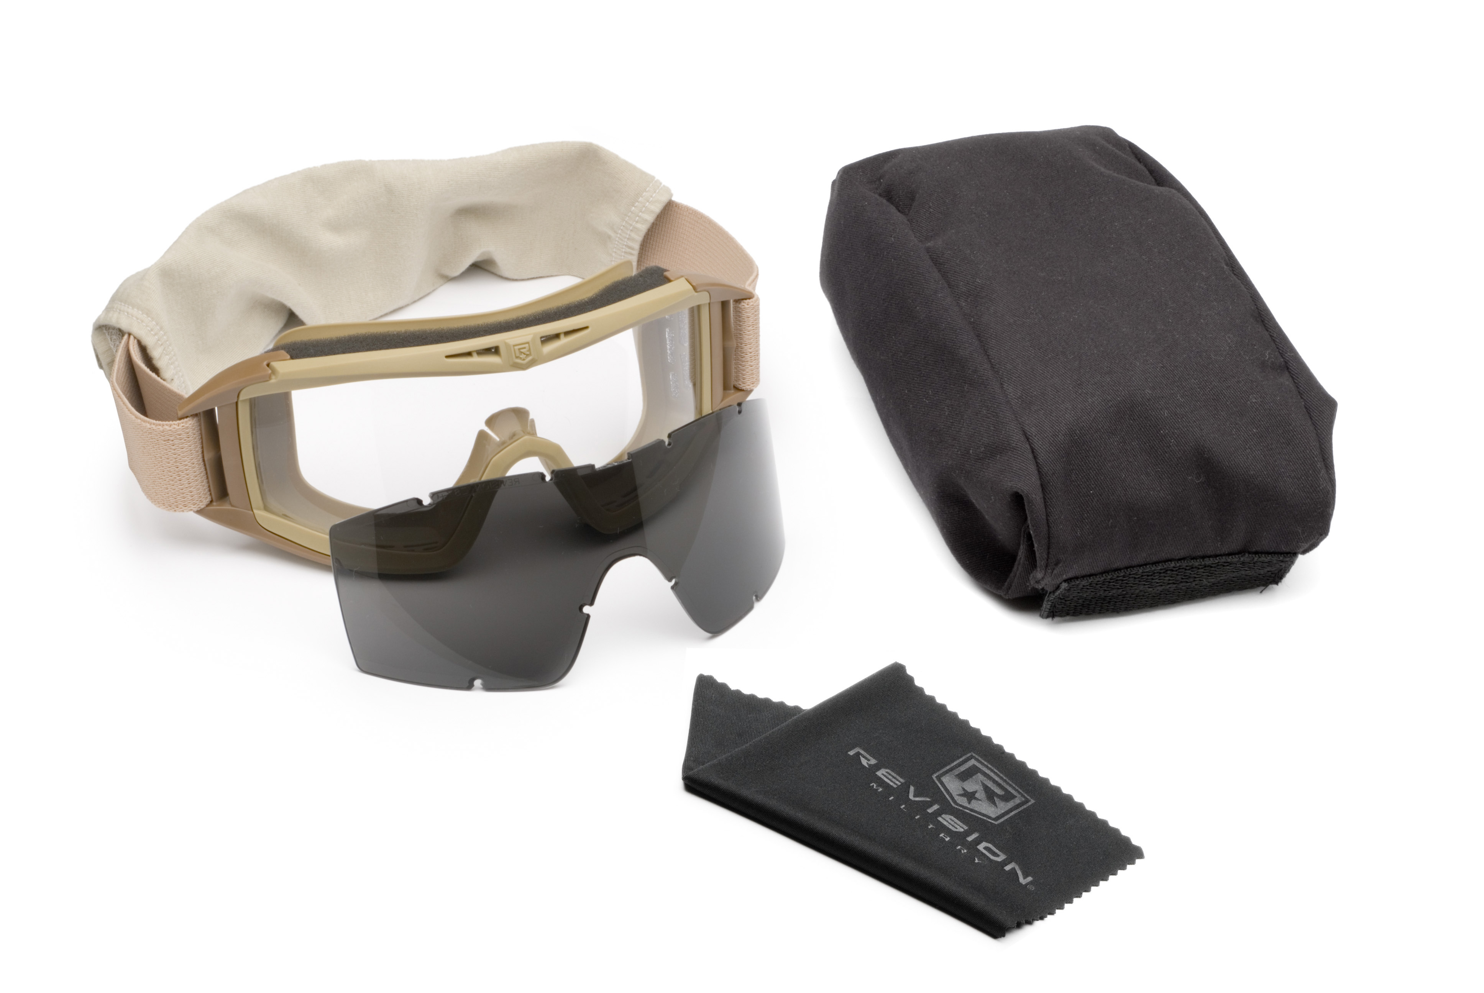
Special Note: If you are selling the two-lens kit (the Desert Locust Essential Kit) the 4th and 9th bullet points above should be changed to:
- Two interchangeable lenses available for various light conditions – Clear and Solar
- Essential Kit also includes protective sleeve, microfiber cloth and storage case

In addition, the Essential Kit photograph is shown here →
Essential Kit shown

Desert Locust® Replacement Lenses
Tough enough to withstand a shot gun blast from 16 ft (5m) away.
- Clear Lenses: Maximizes light transmittance. Use indoors or at night.
- Solar Lenses: Reduces extreme glare and squinting. Use outdoors in bright conditions.
- Yellow High-Contrast±±: Provide crisp definition in low-light conditions. Use during dull, cloudy or hazy conditions.
- Vermillion High-Contrast±±: Provide excellent color recognition and depth perception. Use in bright and cloudy conditions to reduce glare.

*Revision’s eyewear is certified to ANSI Z87.1 – 2010 and military requirements (MIL-DTL-43511D, clause 3.5.10 and MIL-PRF-31013, clause 3.5.1.1). CE certified in accordance with EN 166, EN 170 and EN 172.
±±The High-Contrast specialty lenses are not approved for military use by the U.S. Army

Desert Locust® Fan Goggle System

Designed as the ultimate protective eyewear, the Desert Locust Fan Goggle builds upon Revision’s unmatched ability to protect soldiers’ eyes. In addition to a virtually silent but powerful fan system, Revision’s proprietary Ocumax® coating prevents fogging and scratching to ensure clear vision for the most extreme conditions while the optically correct goggle lens is engineered to maximize field-of-view and provide unprecedented visual clarity.
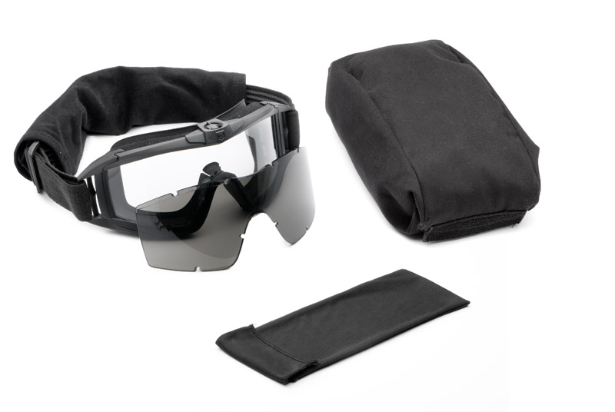
- High-impact*, optical grade polycarbonate lens shields eyes from unexpected fragments and offers 100% protection from UV-A, UV-B and UV-C rays
- High performance OcuMax® coating protects against fogging and scratching; top and lateral forced air vents maximize air circulation; filtration media prevents small particle entry
- Superior anti-scratch hard coating for durability in extreme climatic conditions
- Two interchangeable lenses available for various light conditions – Clear and Solar
- At only 4 ounces, this lightweight goggle can be worn comfortably for hours
Desert Locust Fan Goggle Essential Kit shown
- Pliable frame material and strapping system seals face while maximizing facial comfort
- Low profile design ensures compatibility with helmet, weapon sights, binoculars and night-vision systems
- Tri-speed silent exhausting fan provides constant air-flow for superior fog protection in extreme temperatures
- Fan system operates using a single AA battery for easy field replacement; Energy efficient system and weather-resistant battery casing provide exceptional life for mission performance
- Optional Prescription (Rx) Carrier available ( Also compatible with Sawfly® Spectacles and Bullet Ant® Tactical Goggles)
- Essential Kit also includes protective sleeve, microfiber cleaning cloth and storage case
- Asian Locust Fan Goggle available in Black

Desert Locust® Fan Goggle Replacement Lenses
Tough enough to withstand a shot gun blast from 16 ft (5m) away.
- Clear Lenses: Maximize light transmittance. Use indoors or at night.
- Solar Lenses: Reduce extreme glare and squinting. Use outdoors in bright conditions.
- Yellow High-Contrast±±: Provide crisp definition in low-light conditions. Use during dull, cloudy or hazy conditions.
- Vermillion High-Contrast±±: Provide excellent color recognition and depth perception. Use in bright and cloudy conditions to reduce glare.

*Revision’s eyewear is certified to ANSI Z87.1 – 2010 and military requirements (MIL-DTL-43511D, clause 3.5.10 and MIL-PRF-31013, clause 3.5.1.1). CE certified in accordance with EN 166, EN 170 and EN 172.
±±The High-Contrast specialty lenses are not approved for military use by the U.S. Army

Desert Locust® Goggle PDQ™ Quick Release System
When eye protection must be “at-the-ready” for fast moving and dynamic conditions, the Desert Locust Goggle PDQ Quick Release System meets the challenge. Designed by Special Force Operators, the patented PDQ System allows the wearer to singlehandedly and quickly don or doff the Desert Locust Goggle, depending on the users’ visual and protection requirements. The PDQ is an alternative to a conventional strapping system and is proven to provide functional, comfortable, goggle / helmet integration and operator equipment compatibility.
This unique system is comprised of a NODS-mount compatible “Halo” ring which encircles the perimeter and securely attaches to the helmet. Additionally, left and right straps attached to the Desert Locust Goggle are designed to securely attach by Velcro® to the Halo ring. The PDQ’s ambidextrous, Velcro® break-away allows the user to immediately separate the goggle from the face and out of the way, while still retaining the Desert Locust at-the-ready. Trialed and fielded by U.S. Special Operators and other military forces alike, the PDQ is a combat tested system which meets the needs of those in rapidly changing environments.
- Compatible with all helmet types and sizes
- One-Handed operation - Velcro break-away ensures easy don and doff of Goggle
- NODs Equipment Compatible - Accommodates helmet mounted Night Observation Devices
- Desert Locust Goggle and PDQ system mount securely to the helmet to ensure system is “at-the-ready”
- Accommodates removable soldier ID nametape and IR Flag
- Desert Locust Goggle with PDQ stows on the helmet when not in use
- Flame resistant materials reduce risk of ignition in extreme environments
- Hand or machine washable for easy cleaning
- Available in Tan, Black and Foliage Green (Available in Black only for Asian Locust)
- 100% U.S. Made - Buy American & Berry Amendment-Compliant
- Compatible with Asian Locust Goggle System and Desert Locust Extreme Weather System
